Quiz Questions:

1. List all images

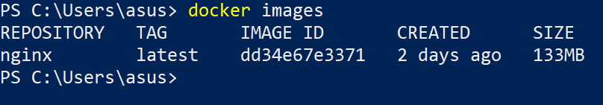

1. List all containers

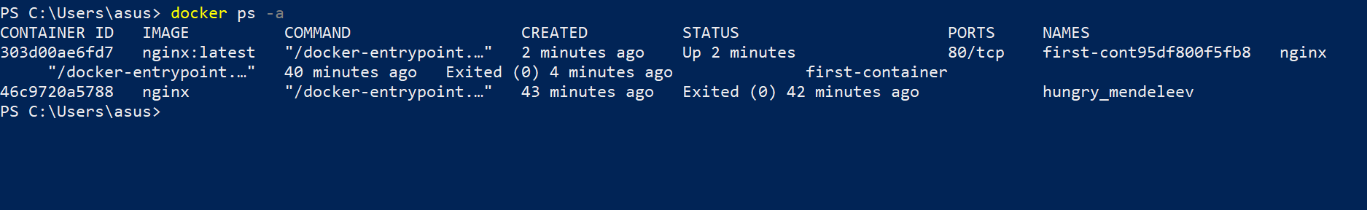

1. Stop a running container forcefully



1. Run a container in background

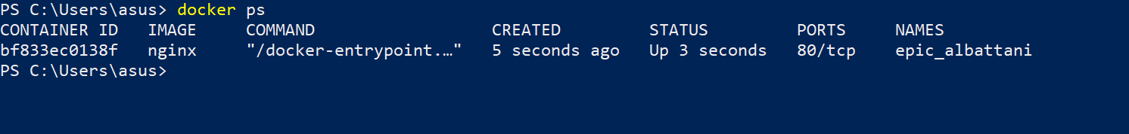

1. Delete a container

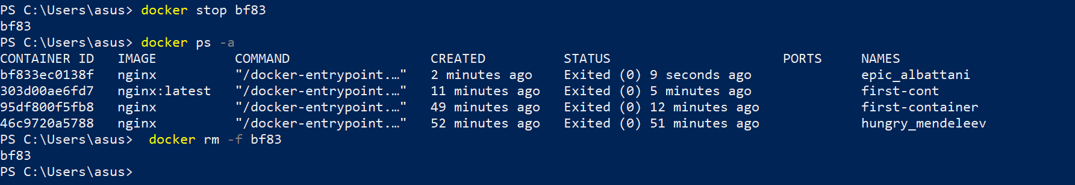

1. Delete an image

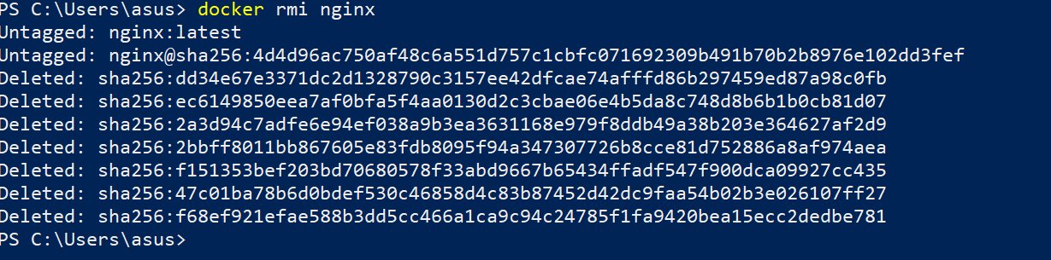

1. List hidden images

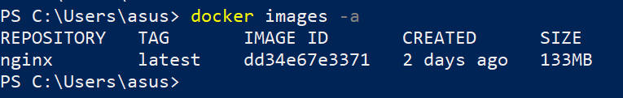

1. List hidden containers



1. Run nginx image directly from docker hub

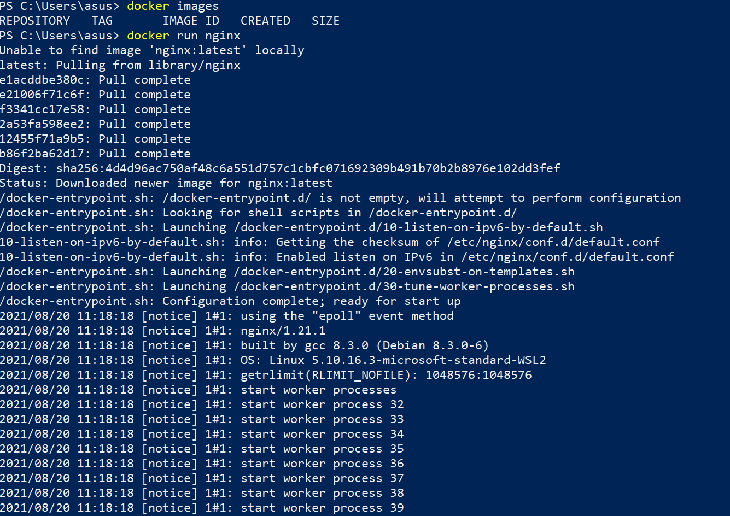

**Note: Some issue here due to personal laptop configuration. Will take some time for the container to run**

1. Create an app which is connected to DB service uing docker compose
2. create docker-compose.yaml

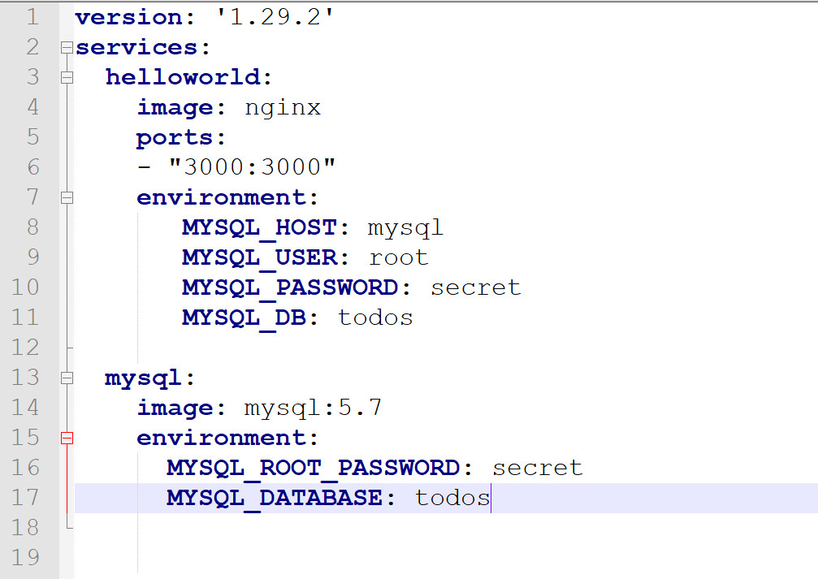

Run the above file using “docker compose up -d” command in the directory.

The logs will show that app is running and is accessible. Also check container status



